H.T No
Regulations:
A19

Sreenidhi Institute of Science and Technology
(An Autonomous Institution)
Code No: 7W102 Date: 23-Oct-2021 (FN)

M.Tech I-Year I-Semester External Examination, Oct/Nov - 2021 (Supplementary)
ADVANCED FINITE ELEMENT ANALYSIS (CADCAM)

Time: 3 Hours Max.Marks:70

Note: a) No additional answer sheets will be provided.
b) All sub-parts of a question must be answered at one place only, otherwise it will not be valued.
c) Missing data can be assumed suitably.

ANSWER ANY 5 OUT OF 8 QUESTIONS. EACH QUESTION CARRIES 14 MARKS.

Bloom's Cognitive Levels of Learning (BCLL)

Remember | L1 | Apply | L3 | Evaluate | L5
Understand | L2 | Analyze | L4 | Create | L6

 |  |  | BCLL | CO(s) | Marks
1. |  | Calculate the solution of the equations  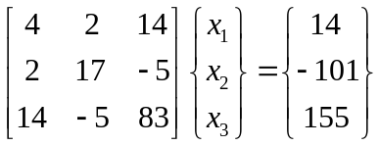  Using the Choleski decomposition of the matrix [A]. | L3 | CO1 | [14M]
2. |  | For the pin-jointed configuration shown in Fig(a), determine  - the stresses in each element  - Reaction forces  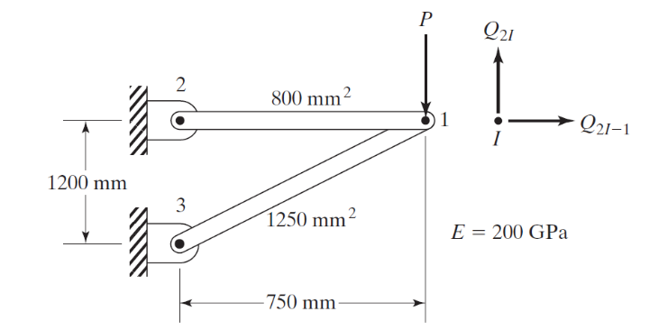  Fig(a) | L4 | CO2 | [14M]
3. | a) | Assess the shape functions N₁, N₂ and N₃ at the interior point P for the triangular element shown in fig(b).  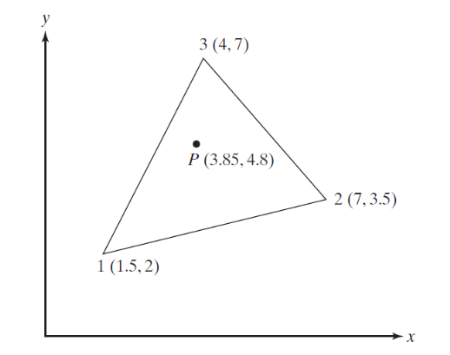  Fig (b) | L5 | CO3 | [7M]
 | b) | Determine the strain-nodal displacement matrices B^{e} for the element show in figure (c). Use local number given at the corners.  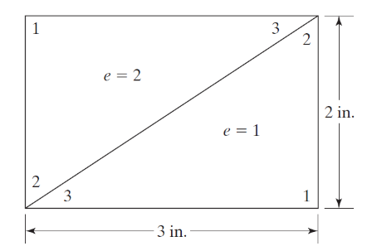  Fig (c) | L5 | CO3 | [7M]
4. |  | Determine Eigen values and Eigen vectors for the stepped bar shown in fig (d).  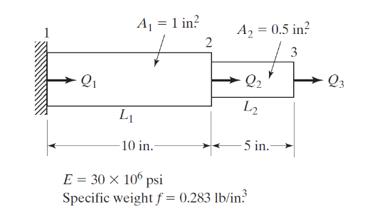  Fig. (d) | L5 | CO4 | [14M]
5. |  | Test the temperature distribution in the one-dimensional fin shown in Fig. (e), using two finite elements.  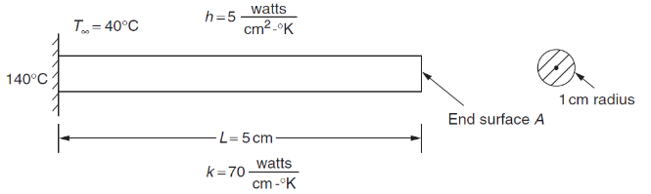  Fig. (e) | L5 | CO5 | [14M]
6. |  | The fluid head at the top is 10 in. and that at the bottom is 1 in. Let the permeability coefficient be K_{xx} = 0.5 in./s. Assume a cross-sectional area of A=1 in².  Determine  - The fluid head distributed along the length of the coarse gravelly medium shown in Fig. (f) and the velocity in the upper part.  - The volumetric flow rate in the upper part  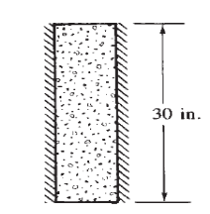  Fig. (f) | L5 | CO6 | [14M]
7. | a) | Name the different methods used to solve the Eigen value problem | L3 | CO1 | [5M]
 | b) | Discuss the Hermite shape functions. | L2 | CO2 | [5M]
 | c) | Explain the isoparametric representation in CST | L2 | CO3 | [4M]
8. | a) | Develop the element mass matrix for one dimensional bar element. | L4 | CO4 | [7M]
 | b) | Develop stiffness matrix for the one dimensional heat conduction element. | L4 | CO5 | [7M]
-- 00 -- 00 –

